Pre-Reading

My Family
In Chinese the character 的（de）signifies possession, and combined with 我, it simply changes “I” to “my,” also notice that the pinyin does not have a tone, some characters without tones. The third character 家 (jia1) means both family and home. Here, because it is followed by 人 (ren2) ，which means person, it literally means family members. So in Chinese you could say things like 回家 (hui2jia1), which means to return home, or 我家有钱 (wo3jia1you3qian2), which means my family has money, or my family is well-off. You may have noticed that in the sentence “my family is well-off” 的 was not included. As you will learn later in your Chinese studies, 的 is not always needed when forming possessive structures, especially when there are multiple possessives in one sentence. For now, and at least until you learn the exceptions, you should use 的 when constructing possessive sentences. The following character 有 (you3) means “to have.” Here, because it is followed by 点儿 (dian3 er) “a little”, 有点儿 literally translates to “has a little,” or in proper English, “is a little” 奇怪 (qi3 guai4) "strange." In the following sentences the first new character is 爸爸 (ba4ba) "father." At the top of the character is 父 fu, which means “father,” and at the bottom, 巴 （ba）, which gives the character its sound. The two characters at the end of the sentence are 小偷 (xiao3 tou1), the first being "small" and the second being “to steal.” Thus, in Chinese a “small to steal” actually translates to a "petty thief." In the third sentence, the first new word is 妈妈 (ma1ma) "mother." So, Fred老师的mother is a 校长 (xiao4zhang3), "headmaster," or as we say in the U.S., "superintendent." The first character 校 means campus and the second character 长 means leader. In the following sentences, 她 (ta1) means “she.” Here it is important to mention one of the peculiarities of Chinese, which is that "he" "she" and "it" are all pronounced exactly the same. However, the characters are written differently: she 她, he 他, and it 它. In other words, when listening to Chinese speak about others, the gender is not evident unless followed by context clues. Also it is important to notice that the left side of 她 is a 女 radical which means woman and the left side of the 他 character is a man radical. 她 is followed by the character 在 (zai4) "at," the most common Chinese preposition. Next you will see大学 (da4xue2), which means big school or University. If we change the 大 character for 小（xiao3）which means small then we have 小学 which means elementary. The next character we have is 工作 (gong1zuo4) which means “to work.” The last family member that we see here is 妹妹 (mei4mei) which means little sister, in Chinese little sister and big sister and little brother and big brother are all separate words. The next character is 还 (hai2), which here means “still,” but it can have another pronunciation which is （huan2）which means to return something, you’ll have to guess this from context. Finally, the last word 上 (shang4) also has many meanings it can mean to get on, or to go up, or it can be an adjective, however it simply means to be in. 上大学 , to be in university.
Story Character Count = 45
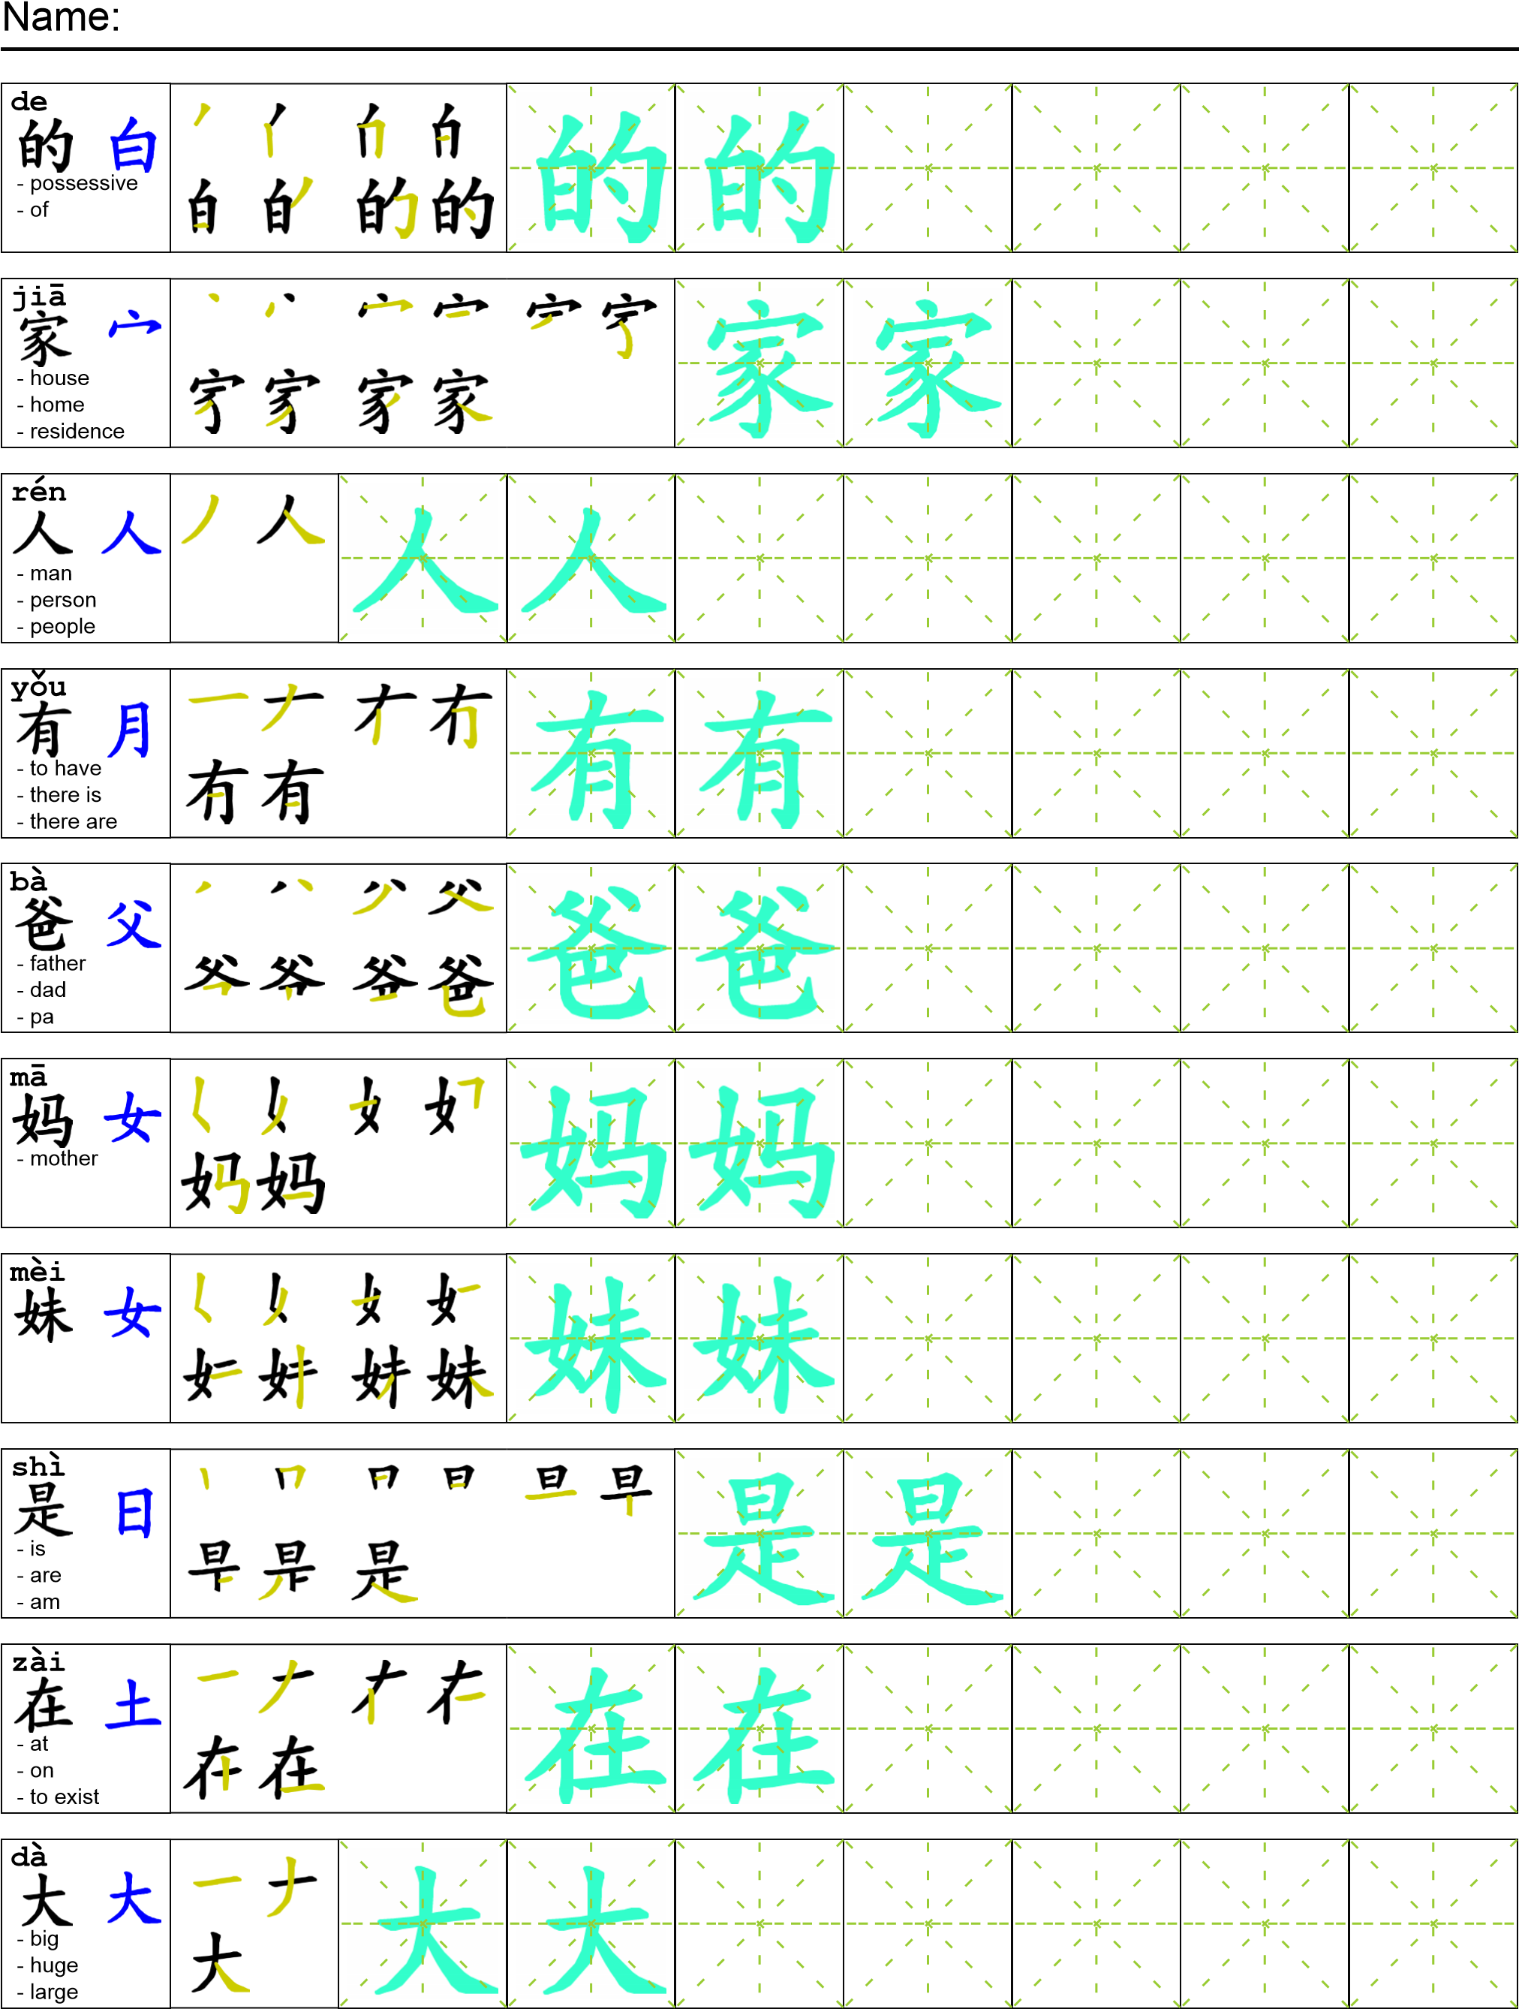
Vocabulary/Writing

Reading

我的家人有点儿奇怪。我爸爸是一个小偷。他偷了很多的东西。我妈妈是个校长。她在大学工作。我妹妹还上大学。
Task Completion

Once all tasks are complete turn the assignment in to collect the points for the project.
Task 1: Trace the vocabulary and the copy the story into your notebook.

Task 2: Answer Comprehension Questions.

Task 3: Write the Pinyin for the Reading.

Task 4: Translate the Reading into English.

Task 5: Record yourself reading the passage.

Comprehension Questions
- What is wrong with the Author’s family? ____________________________________________
- What does the author’s 妈妈 do? __________________________________________________
- What does the author’s 妹妹 do? __________________________________________________
- In Chinese what is the difference between he, she, and it? ______________________________
- Some of the characters in this story are top-bottom characters and others are side-side characters below make a list of top-bottom characters and side-side characters in this text.
Top-Bottom Side-side

